**Aim:** To understand terraform lifecycle, core concepts/terminologies and install it on a Windows Machine.

**Terraform:**

* Terraform is an infrastructure as code (IaC) tool that allows you to build, change, and version infrastructure safely and efficiently.
* This includes low-level components such as compute instances, storage, and networking, as well as high-level components such as DNS entries, SaaS features, etc.
* Terraform can manage both existing service providers and custom in-house solutions.

**Steps With Screenshots:**

* Download “terraform” zip file from <https://www.terraform.io/downloads.html>

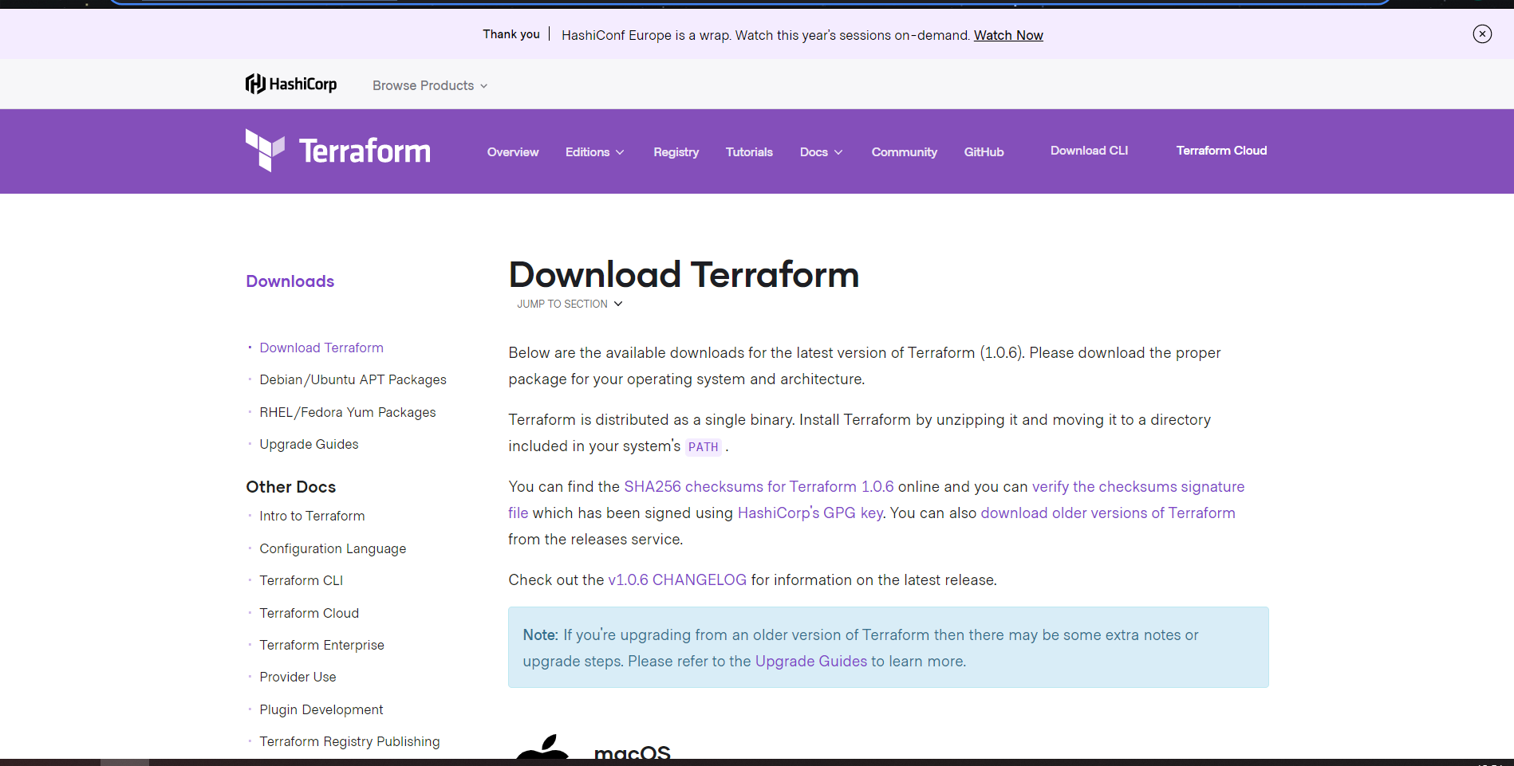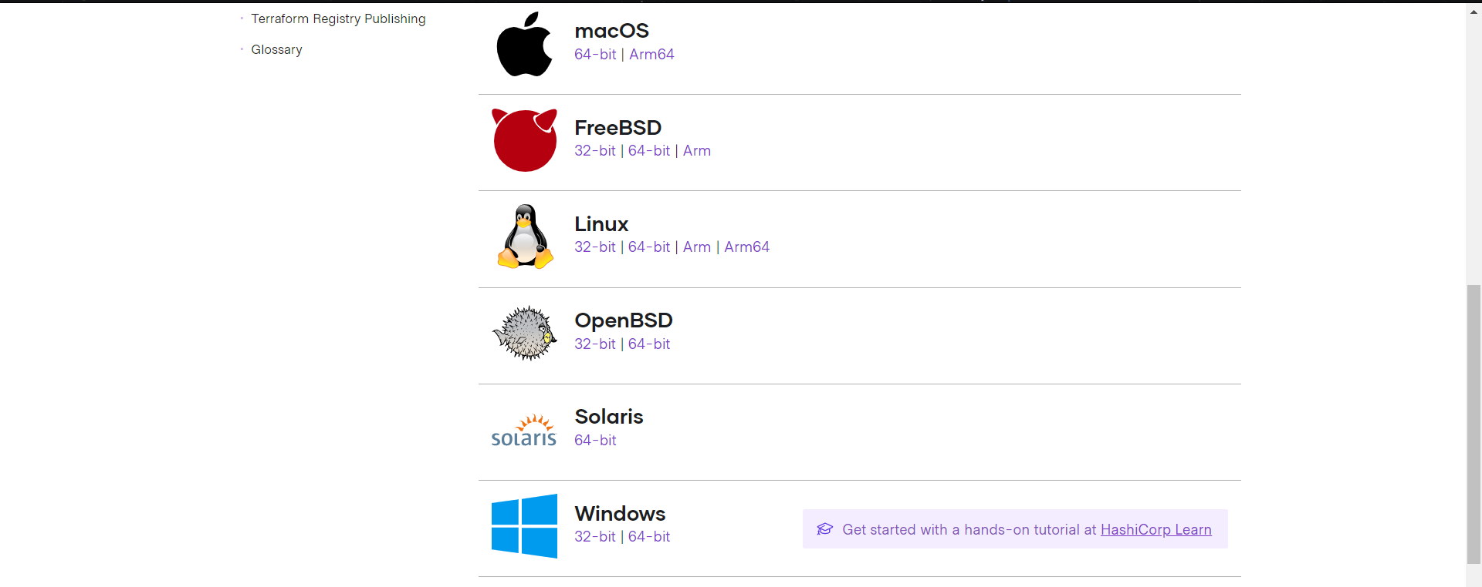

* Extract the zip file in a folder

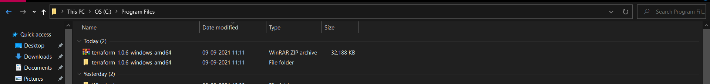

* Add the terraform folder path in “Environment Variables” under “Advance System Settings”

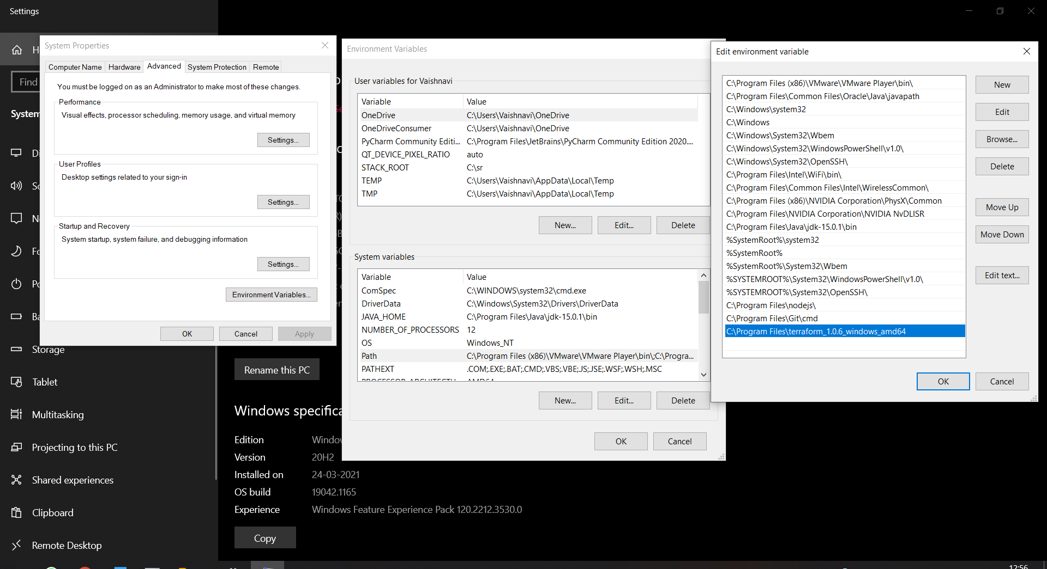

* To check if “terraform” is installed or not type “terraform” in command prompt(run it as a administrator)

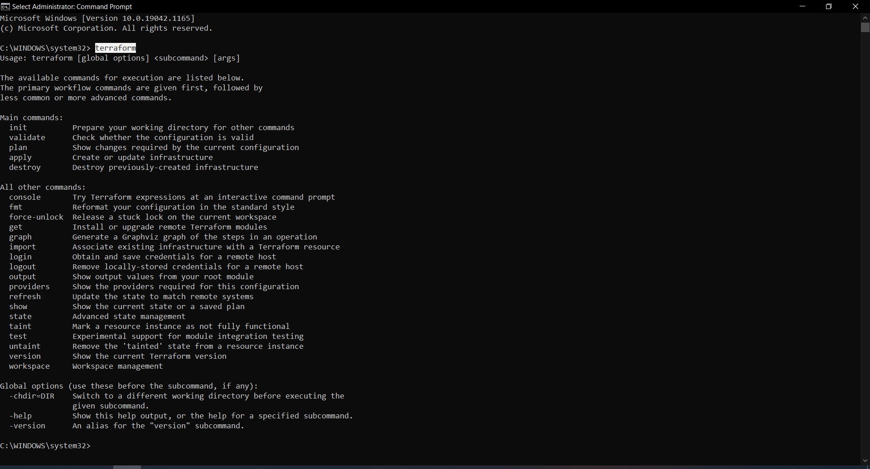

**Conclusion:**

In this experiment we got know what is terraform, various core concepts of terraform and lifecycle of terraform also we successfully installed terraform in our windows machine and verified it in command prompt by running “terraform”.

**Lab Outcome: ITL504**  
To apply best practices for managing infrastructure as code environments and use terraform to define and deploy cloud infrastructure.